**Experiment No. 2**

**Title:** Implementation of Uninformed search algorithm – BFS

**Batch: IAI-2 Roll No.: 16010422234 Experiment No.: 2**

**Aim:** To implement BFS - Uninformed search algorithm in state space

**Resources needed:** C / C++ / Java / Python

**Theory**

Intelligent agents are supposed to maximize the performance measure. The problem solving

agents start with the activity of goal formulation where, it organizes the behaviour by limiting the objectives that the agent is trying to achieve. Then comes the problem formulation which the process of deciding what actions and state to consider, given a goal. These (legal) actions when applied to initial state, gives us the entire state-space.

The state-space leaves the agent with several immediate options of unknown value where the agent can decide what to do next by first examining different possible sequences of actions that lead to states of known value, and then choosing the best one.

The algorithm in uninformed search category:

**BFS:**

These algorithms search trees of nodes, whether that tree is explicit or implicit (generated on the go). The basic principle is that a node is taken from a data structure, its successors examined and added to the data structure. By manipulating the data structure, the tree is explored in level by level order. This method selects the deepest unexpanded node in the search tree for expansion.

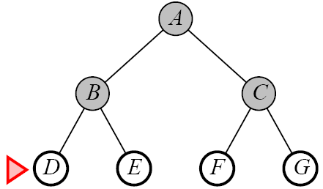 Figure- Breadth First Search

**Algorithm :**

1. Enqueue the root node.

2. Dequeue a node and examine it.

• If the element sought is found in this node, quit the search and return a result.

• Otherwise enqueue any successors (the direct child nodes) that have not yet been discovered.

3. If the queue is empty, every node on the graph has been examined – quit the search and return

not found .

4. If the queue is not empty, repeat from Step 2



**Procedure:**

1. Implement the Mentioned algorithm for BFS for graph search.

2. Output must show the contents of Fringe and Visited nodes for each iteration of graph traversal. Also, finally it must print the path traversed.

**Results: (Softcopy submission of Summary Document) Outcomes:**

**Conclusion:**

**Grade: AA / AB / BB / BC / CC / CD /DD Signature of faculty in-charge with date**

**References:**

1. Stuart Russell and Peter Norvig, Artificial Intelligence: A Modern Approach, Second Edition, Pearson Publication
2. Luger, George F. Artificial Intelligence : Structures and strategies for complex problem

solving , 2009 ,6th Edition, Pearson Education